ANUKEERTHANA S

Module 5 - Spring Core and Maven
Exercise 4: Creating and Configuring a Maven Project
pom.xml
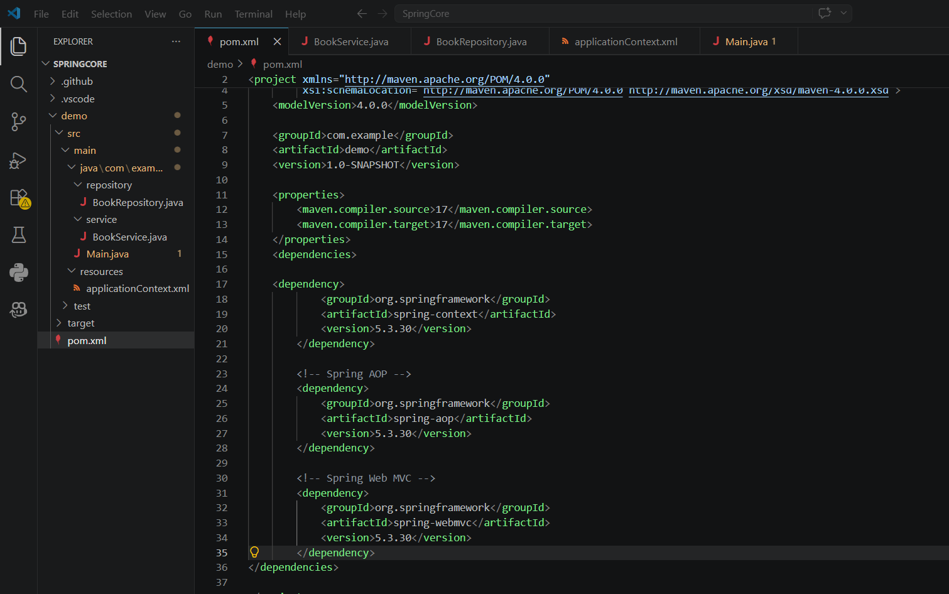
Output
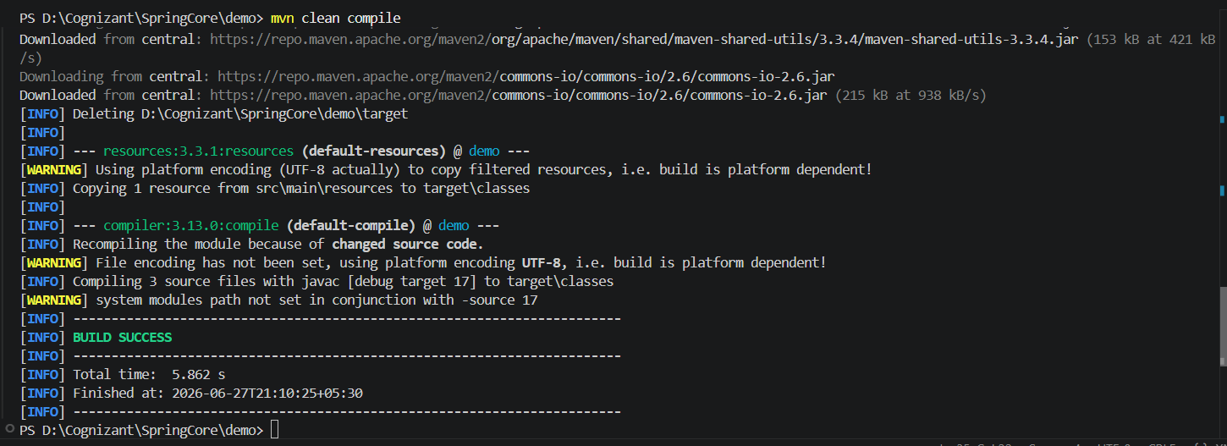
Explanation
Maven
Maven is a build automation and dependency management tool for Java projects. It manages project dependencies, compiles the source code, runs tests, and packages the application.
Spring Context
The Spring Context module provides the Spring IoC container, which manages application beans and dependency injection.
Spring AOP
The Spring AOP module provides Aspect-Oriented Programming support, allowing cross-cutting concerns such as logging, security, and transaction management to be implemented separately from business logic.
Spring Web MVC
The Spring Web MVC module is used for developing web applications following the Model-View-Controller architecture.
Maven Compiler Plugin
The Maven Compiler Plugin specifies the Java version used to compile the project. In this exercise, both the source and target Java versions are set to 1.7.

